Báo cáo Thực hành lập trình hướng đối tượng

Table of Contents

Use case diagram 2

2

Update Aims class diagram 2

2

1. Swing components 4

1.1. AWTAccumulator 4

1.1.1. Create class AWTAccumulator 4

1.1.2. Explanation 6

6

6

6

6

1.2. SwingAccumulator 6

1.2.1. Create class SwingAccumulator 6

1.2.2. Explanation 8

1.3. Compare Swing and AWT elements 9

2. Organizing Swing components with Layout Managers 13

2.1. Swing top-level and secondary-level containers 13

2.2. Using JPanel as secondary-level container to organize components 13

2.2.1. Create class NumberGrid 13

13

2.2.2. Adding buttons 14

14

2.2.3. Complete inner class ButtonListener 15

15

2.2.4.Result 15

3. Create a graphical user interface for AIMS with Swing 16

3.1. View Store Screen 16

3.1.1. Create the StoreScreen class 16

16

3.1.2. The NORTH component 16

16

3.1.3. The CENTER component 18

3.1.4. The MediaStore class 19

19

3.1.5. Putting it all together 20

20

3.2. Adding more user interaction 20

20

4. JavaFX API 22

4.1. Create the FXML file 22

4.1.1. Create and open the FXML file 22

4.1.2. Building the GUI 22

22

4.2. Create the controller class 25

25

4.3. Create the application 26

26

4.4. Practice exercise 27

27

5. Setting up the View Cart Screen with ScreenBuilder 27

5.1. Setting up the BorderPane 27

27

5.2. Setting up the TOP area 28

28

5.3. Setting up the CENTER area 29

5.4. Setting up the RIGHT area 30

6. Integrating JavaFX into Swing application – The JFXPanel class 31

7. View the items in cart – JavaFX’s data-driven UI 32

32

8. Updating buttons based on selected item in TableView – ChangeListener 33

33

9. Deleting a media 34

34

10. Filter items in cart – FilteredList 34

34

11. Complete the Aims GUI application 35

35

12. Check all the previous source codes to catch/handle/delegate runtime exceptions 37

13. Create a class which inherits from Exception 38

38

14. Update the Aims class 39

39

**Sửa equals trong Media Class** 42

# Use case diagram

# 

# Update Aims class diagram

# 

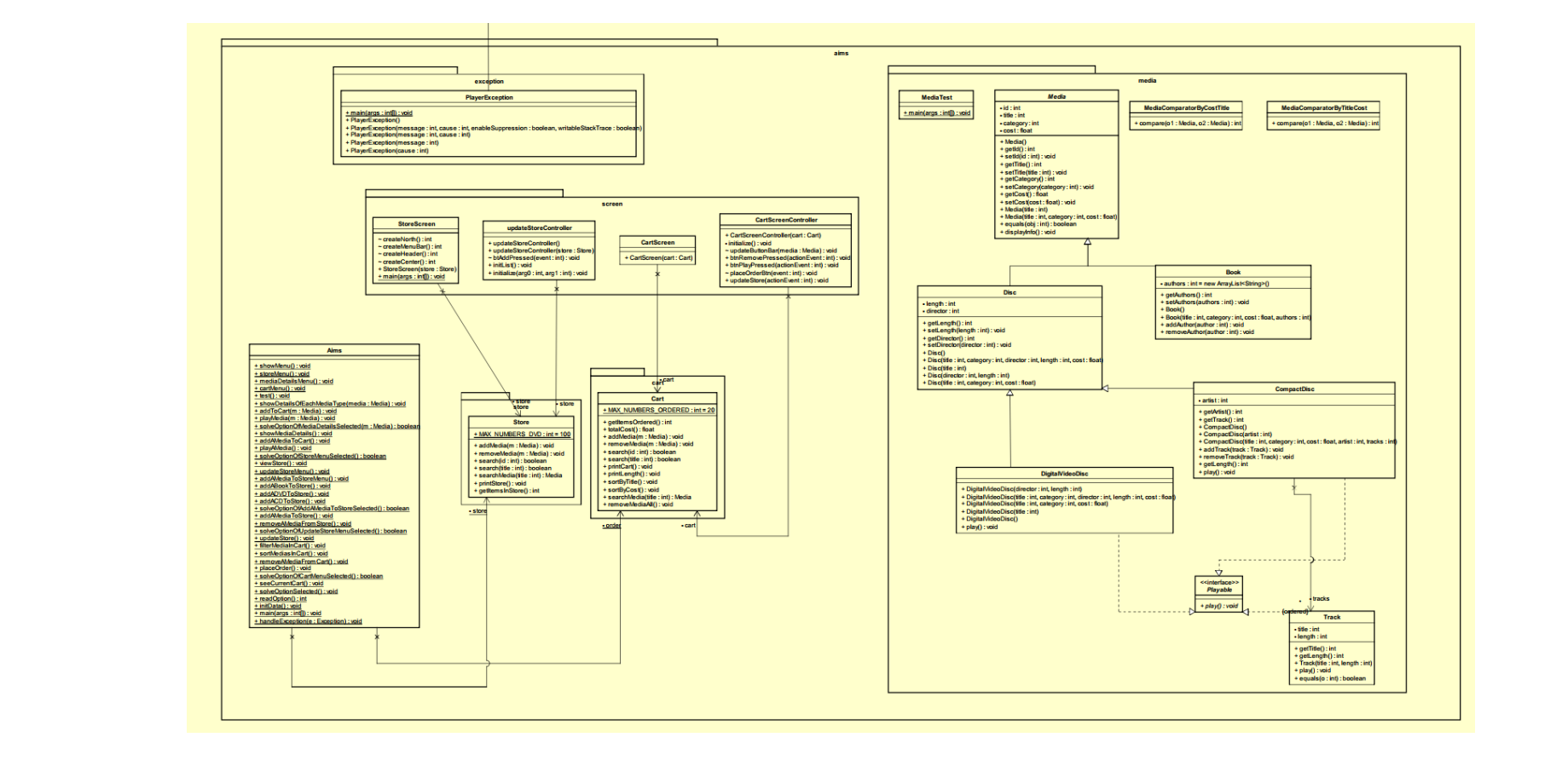

# 1. Swing components

## 1.1. AWTAccumulator

### 1.1.1. Create class AWTAccumulator

### 1.1.2. Explanation

## 1.2. SwingAccumulator

### 1.2.1. Create class SwingAccumulator

### 1.2.2. Explanation

## 1.3. Compare Swing and AWT elements

**The top-level containers in Swing and AWT**

|  |  |  |
| --- | --- | --- |
| Frame (java.awt.Frame): | Dialog (java.awt.Dialog): | Window (java.awt.Window): |
| * Represents a top-level window with a title and border. * Basic structure for creating standalone applications. | * Represents a pop-up window or a dialog box. * Used for getting user input or displaying information. * Can be modal or modeless. | * Base class for `Frame` and `Dialog`. * Represents a top-level window with no borders or title. |

**Swing Top-Level Containers:**

|  |  |  |  |
| --- | --- | --- | --- |
| JFrame (javax.swing.JFrame) | . JDialog (javax.swing.JDialog): | . JWindow (javax.swing.JWindow): | 4. JApplet (javax.swing.JApplet): |
| * Swing equivalent of AWT's `Frame`. * Represents a top-level window with decorations (title, border, etc.). * Supports Swing components and features. | * Swing equivalent of AWT's `Dialog`. * Represents a pop-up window or a dialog box. * Can be modal or modeless. | * Swing equivalent of AWT's `Window`. * Represents a top-level window without decorations. | * Used for creating Swing-based applets. * Extends AWT's `Applet` class and is designed for use in a web browser. |



**The class name of components in AWT and corresponding class’s name in Swing** In AWT and Swing, many components share similar functionalities, but they are represented by different classes. Below is a comparison of some common components in AWT and their counterparts in Swing:

1. Button:

* AWT: `java.awt.Button`
* Swing: `javax.swing.JButton`

2. Label:

* AWT: `java.awt.Label`
* Swing: `javax.swing.JLabel`

3. TextField:

* AWT: `java.awt.TextField`
* Swing: `javax.swing.JTextField`

4. TextArea:

* AWT: `java.awt.TextArea`
* Swing: `javax.swing.JTextArea`

5. Checkbox:

* AWT: `java.awt.Checkbox`
* Swing: `javax.swing.JCheckBox`

6. CheckboxGroup:

* AWT: `java.awt.CheckboxGroup`
* Swing: `javax.swing.ButtonGroup` (used with `JRadioButton`)

7. Choice:

* AWT: `java.awt.Choice`
* Swing: `javax.swing.JComboBox`

8. List:

* AWT: `java.awt.List`
* Swing: `javax.swing.JList`

9. Scrollbar:

* AWT: `java.awt.Scrollbar`
* Swing: `javax.swing.JScrollBar`

1. **Panel:**
   * AWT: `java.awt.Panel`
   * Swing: `javax.swing.JPanel`

1. Frame:
   * AWT: `java.awt.Frame`
   * Swing: `javax.swing.JFrame`

1. Dialog:
   * AWT: `java.awt.Dialog`
   * Swing: `javax.swing.JDialog`

1. Window:
   * AWT: `java.awt.Window`
   * Swing: `javax.swing.JWindow`

1. Applet:
   * AWT: `java.applet.Applet`
   * Swing: `javax.swing.JApplet`

1. Canvas:
   * AWT: `java.awt.Canvas`
   * Swing: `javax.swing.JPanel` (used for custom painting)

1. Label:
   * AWT: `java.awt.Label`
   * Swing: `javax.swing.JLabel`

1. MenuBar:
   * AWT: `java.awt.MenuBar`
   * Swing: `javax.swing.JMenuBar`

1. Menu:
   * AWT: `java.awt.Menu`
   * Swing: `javax.swing.JMenu`

1. MenuItem:
   * AWT: `java.awt.MenuItem`
   * Swing: `javax.swing.JMenuItem`

1. CheckboxMenuItem:
   * AWT: `java.awt.CheckboxMenuItem`

Swing: `javax.swing.JCheckBoxMenuItem`

# 2. Organizing Swing components with Layout Managers

## 2.1. Swing top-level and secondary-level containers

## 2.2. Using JPanel as secondary-level container to organize components

### 2.2.1. Create class NumberGrid

### 2.2.2. Adding buttons

### 2.2.3. Complete inner class ButtonListener

### 2.2.4.Result

# 3. Create a graphical user interface for AIMS with Swing

## 3.1. View Store Screen

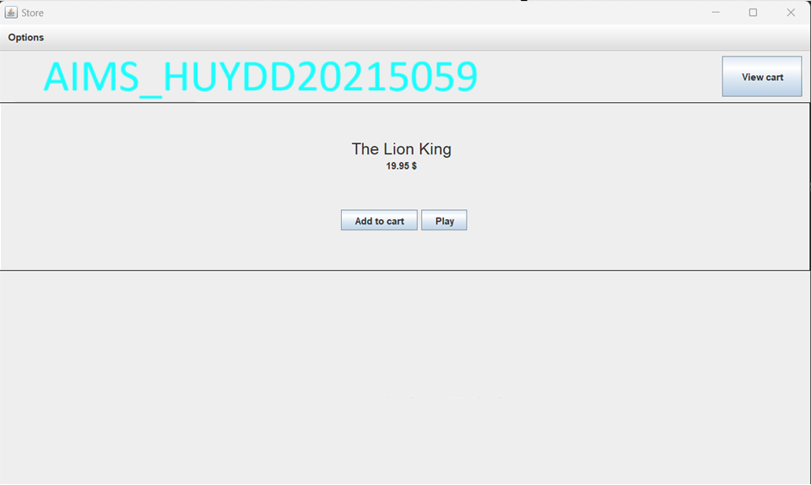

### 3.1.1. Create the StoreScreen class

### 3.1.2. The NORTH component

Create the method createNorth(), which will create our NORTH component:

Create the method createMenuBar():

Create the method createHeader():

### 3.1.3. The CENTER component

### 3.1.4. The MediaStore class

### 3.1.5. Putting it all together

## 3.2. Adding more user interaction

## 

Result:

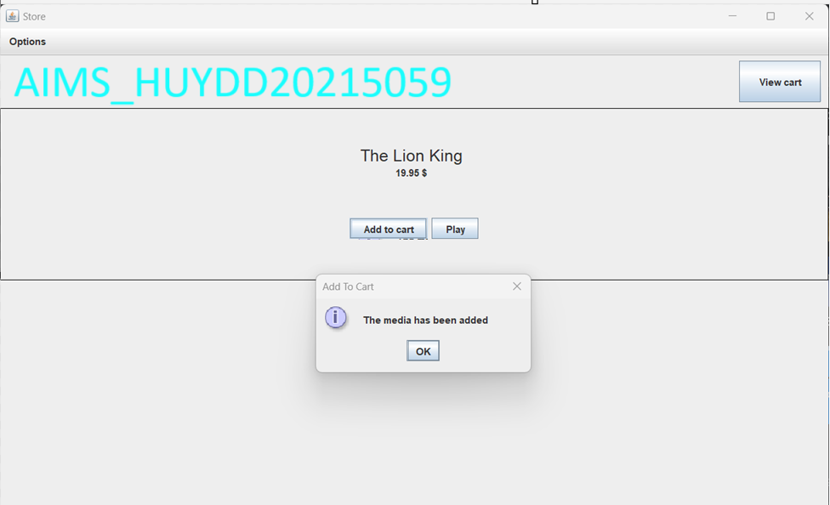

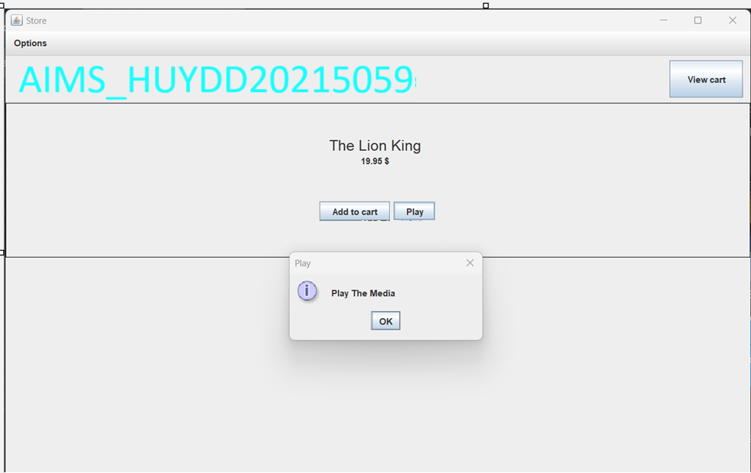

# 4. JavaFX API

## 4.1. Create the FXML file

### 4.1.1. Create and open the FXML file

### 4.1.2. Building the GUI

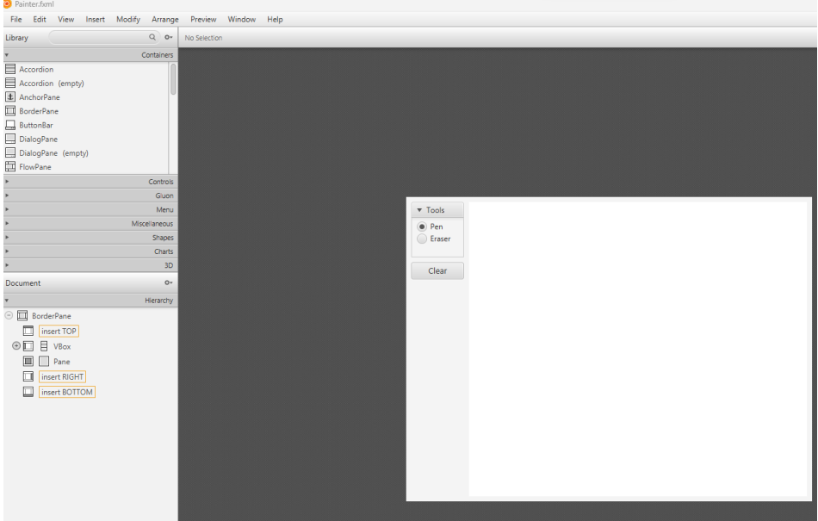

## 4.2. Create the controller class

## 

## 4.3. Create the application

## 4.4. Practice exercise

## 

# 5. Setting up the View Cart Screen with ScreenBuilder

## 5.1. Setting up the BorderPane

## 5.2. Setting up the TOP area

## 

## 5.3. Setting up the CENTER area

## 5.4. Setting up the RIGHT area

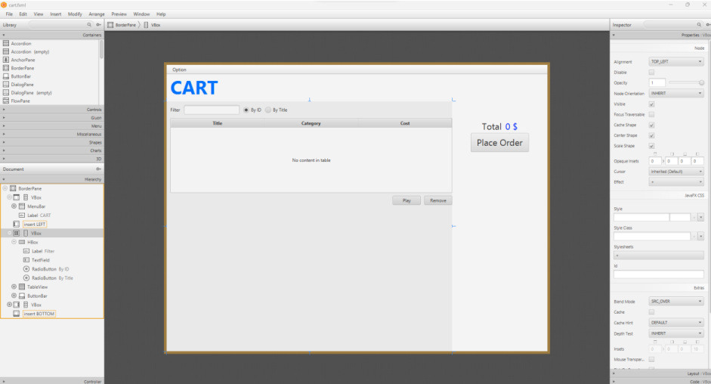

# 6. Integrating JavaFX into Swing application – The JFXPanel class

# 7. View the items in cart – JavaFX’s data-driven UI

SỬA ĐỔI CLASS

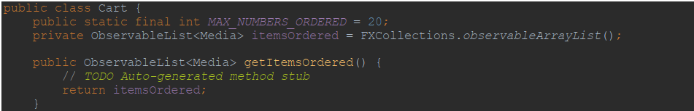

# 8. Updating buttons based on selected item in TableView – ChangeListener

# 9. Deleting a media

# 10. Filter items in cart – FilteredList

# 11. Complete the Aims GUI application

Result:

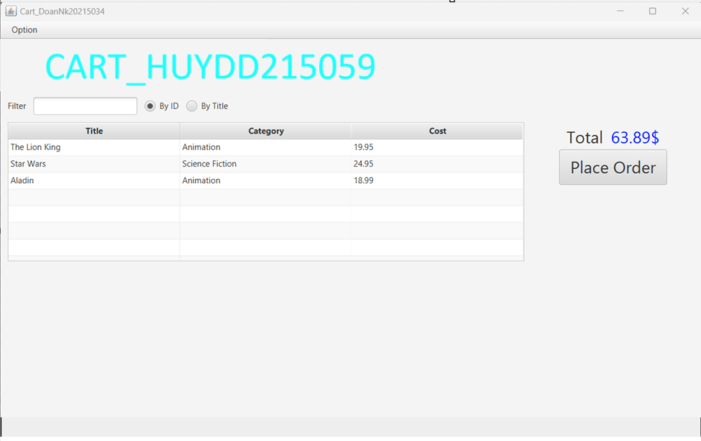

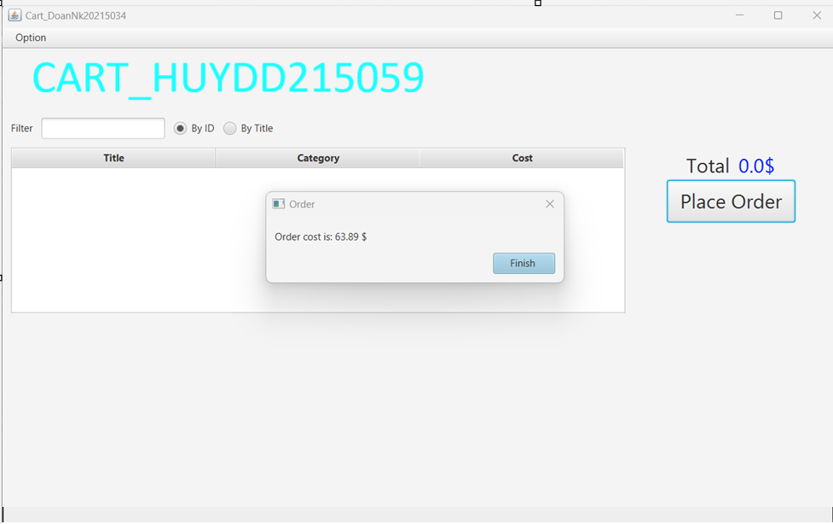

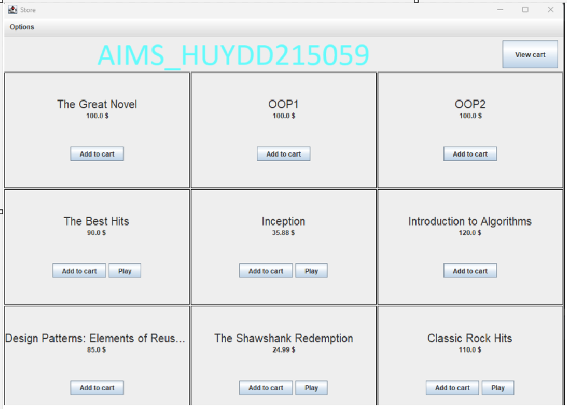

# 12. Check all the previous source codes to catch/handle/delegate runtime exceptions

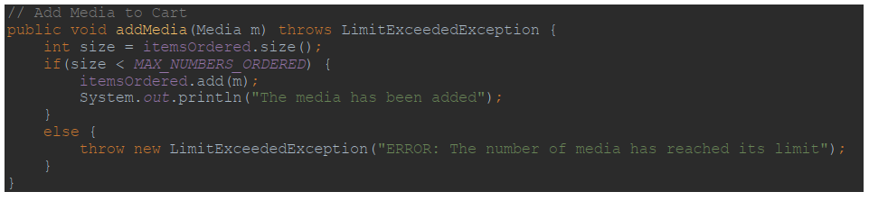

# 13. Create a class which inherits from Exception

# 14. Update the Aims class

15. Update the Aims class

## Sửa equals trong Media Class

